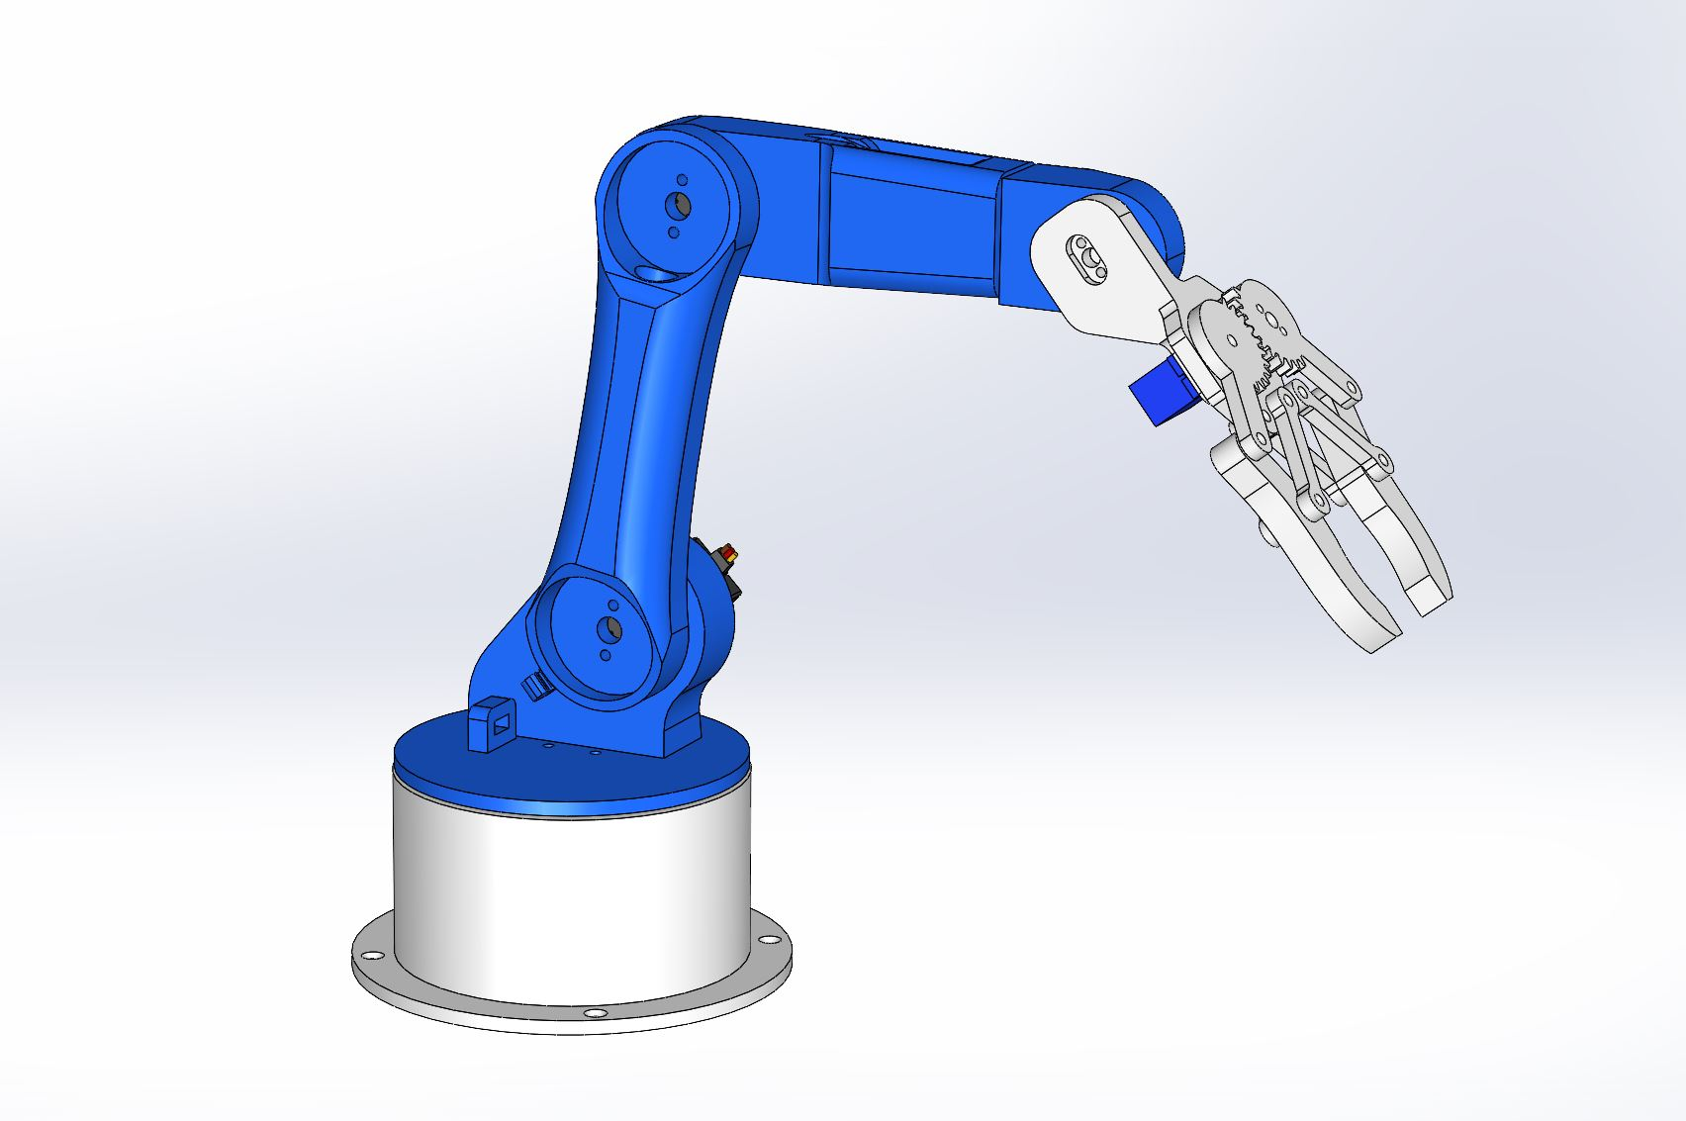
3D MODELLING OF 5DOF ROBOTIC ARM
BASE
SHOULDER/WAIST
ELBOW1
ELBOW1
GRIPPER

BASE OF THE ROBOTIC ARM

- Draw two circles, one with a diameter of 90mm and the other with a diameter of 121.25mm, and then proceed to the "features" section and extrude both circles to a thickness of 4mm.
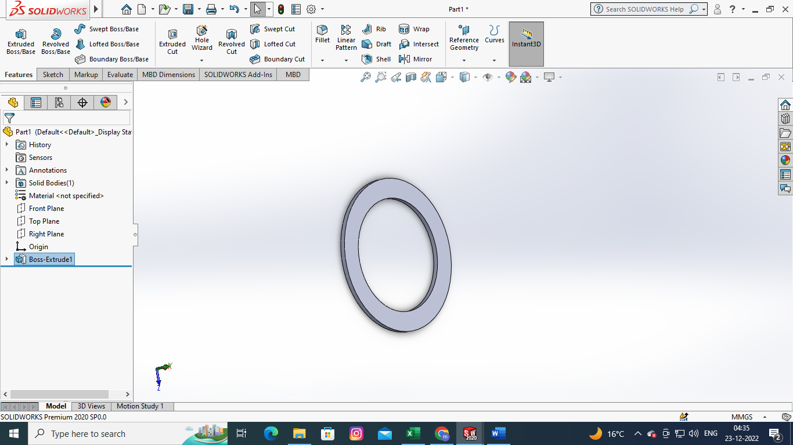
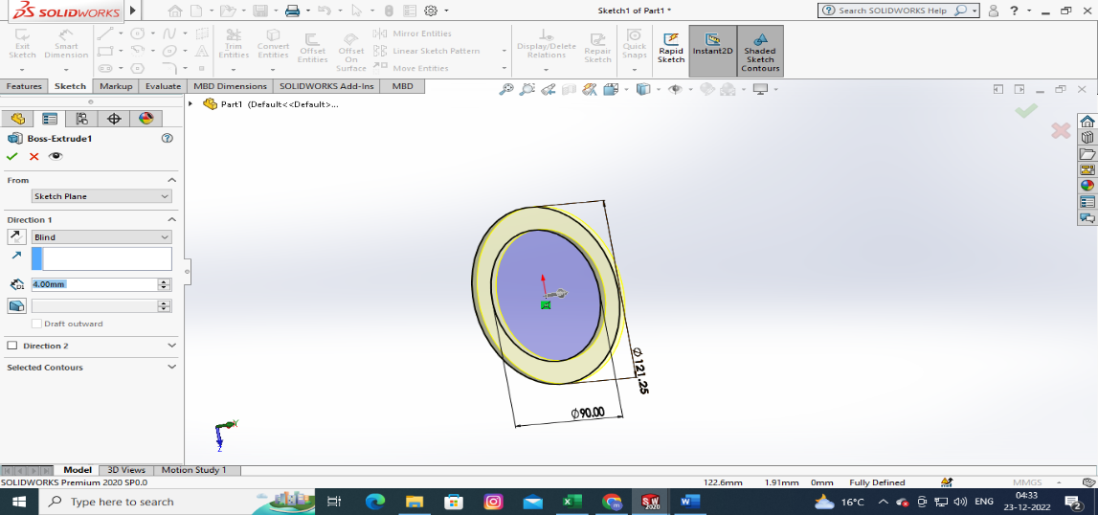
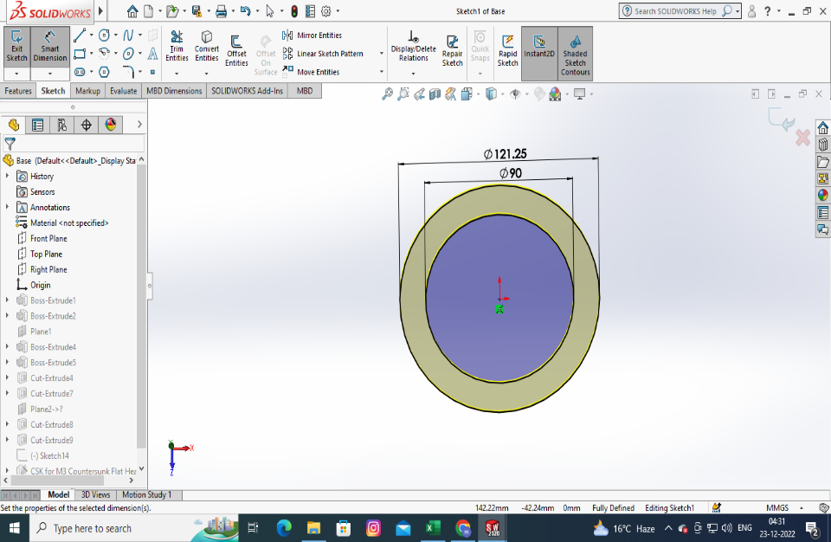

- Draw a circle with a diameter of 90mm and another circle with a diameter of 98mm. Then, select features and extrude on the second circle to a height of 52mm.

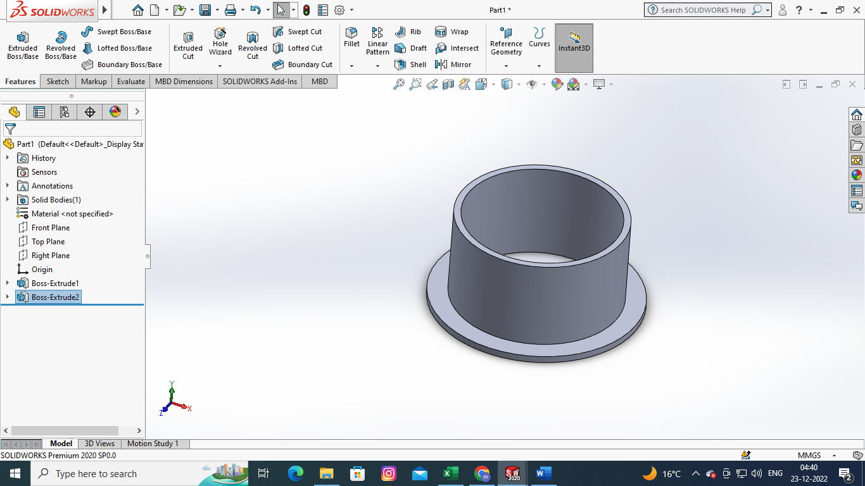
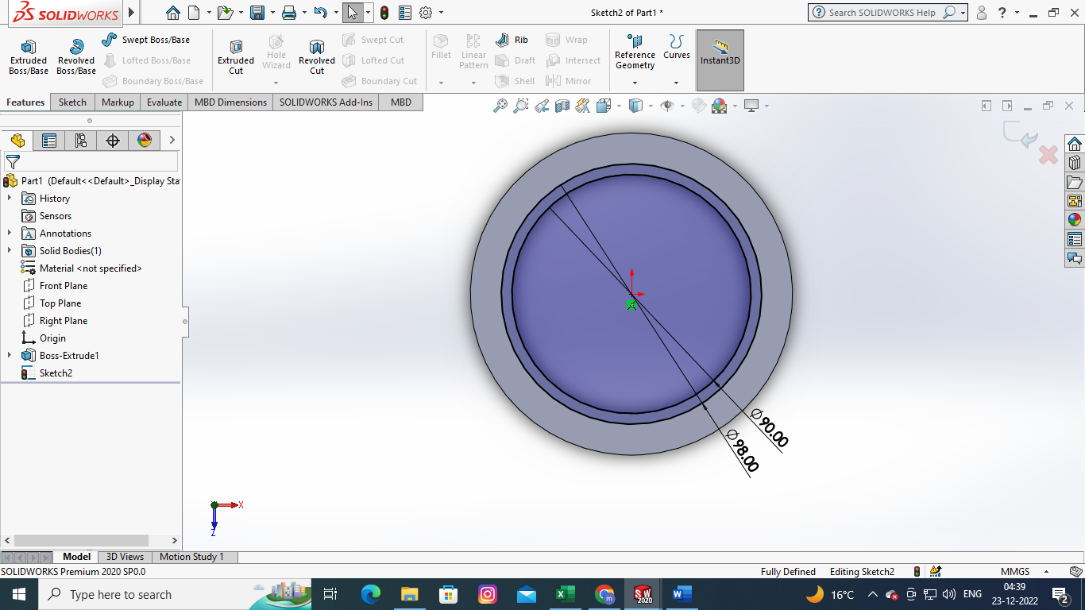

- Create a reference plane : Go to reference geometry select plane Select face and distance of the plane 20mmselect flip offset
Sketch on reference plane : go to front plane sketch draw a line draw the servo motor braces as shown in the fig

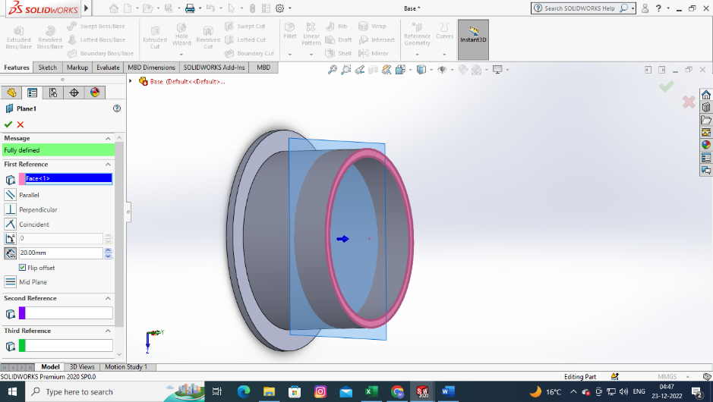
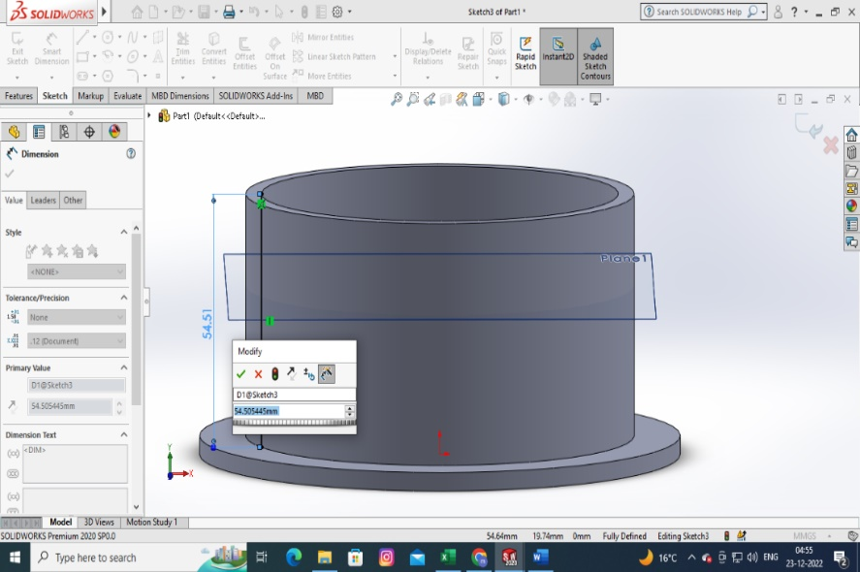

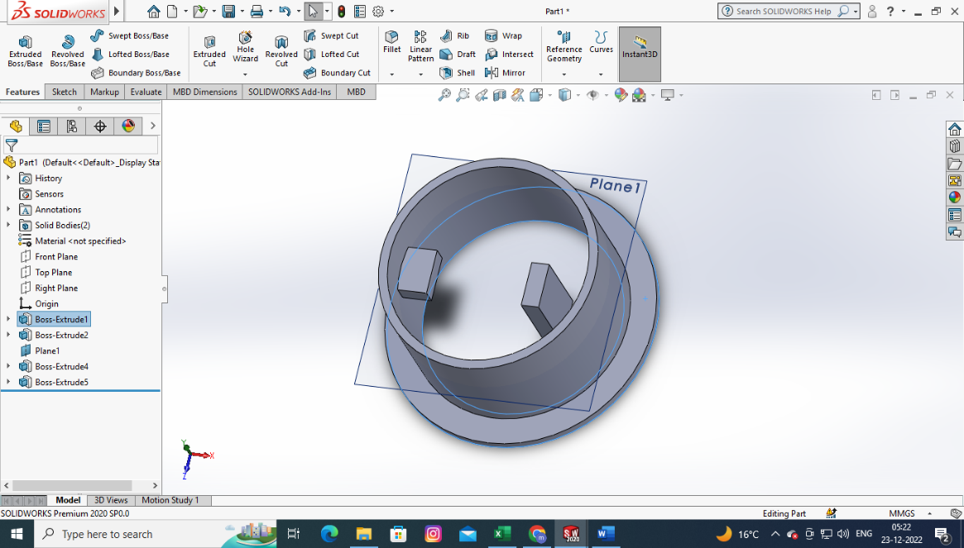
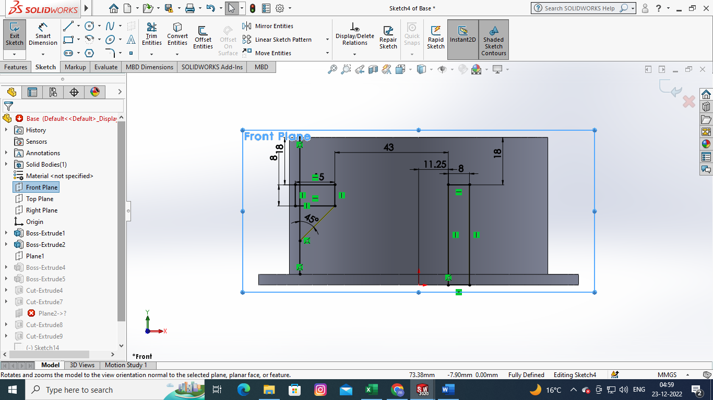

draw support for servo motor braces and extrude it to 10mm
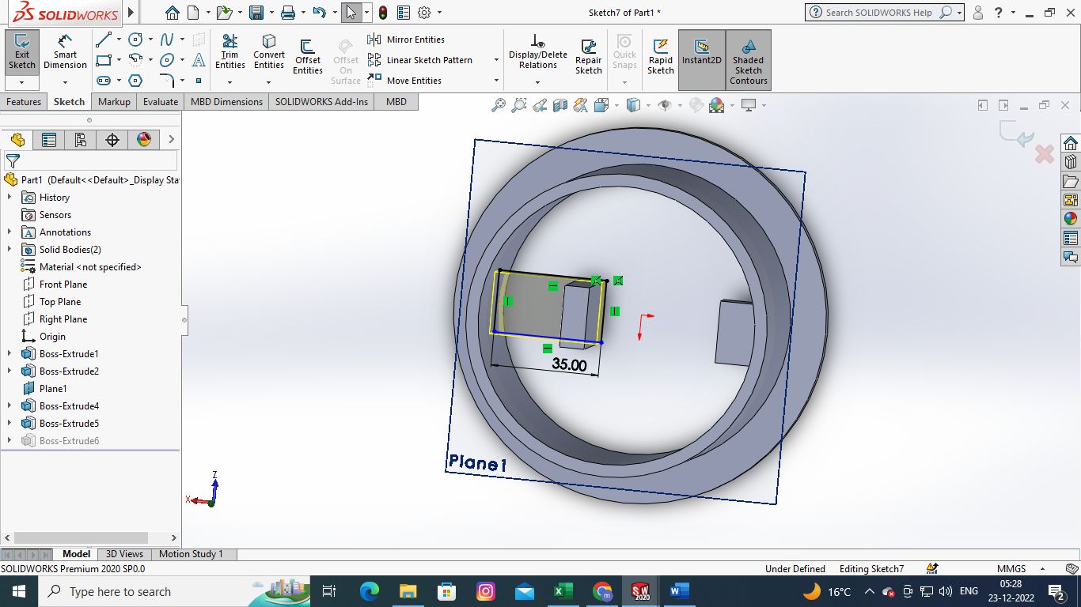

create screw slots on the servo braces design screw space with following dimensions and extrude cut to 5mm.
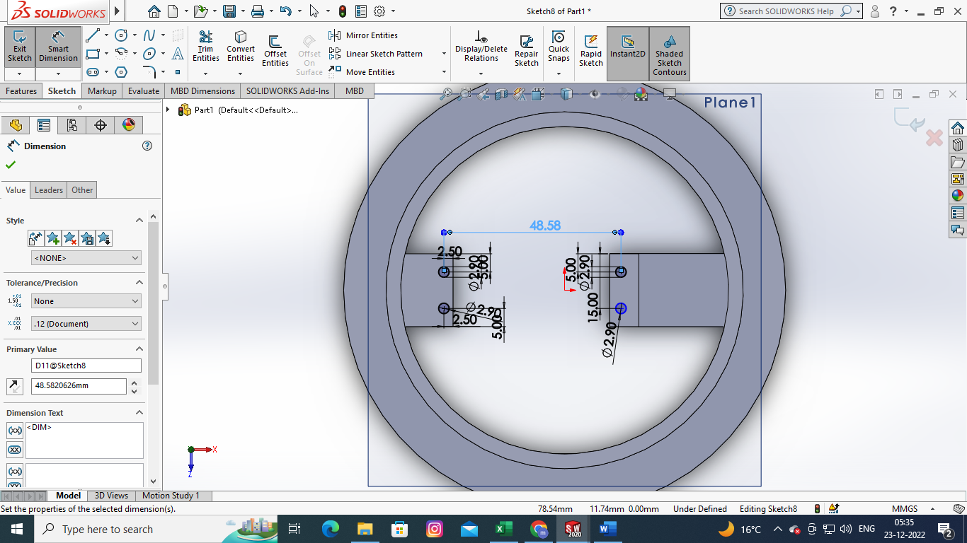

SHOULDER OF THE ROBOTIC ARM

- Sketch a circle of 97mm extrude to 4mm -> Select the plane and draw rectangle of 22*60mm

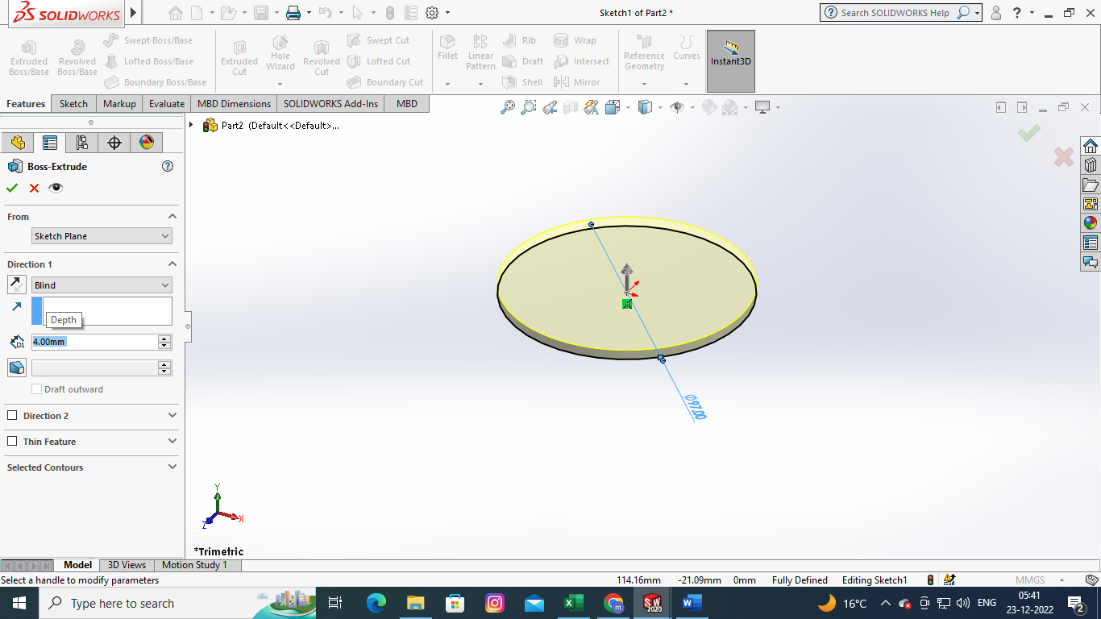
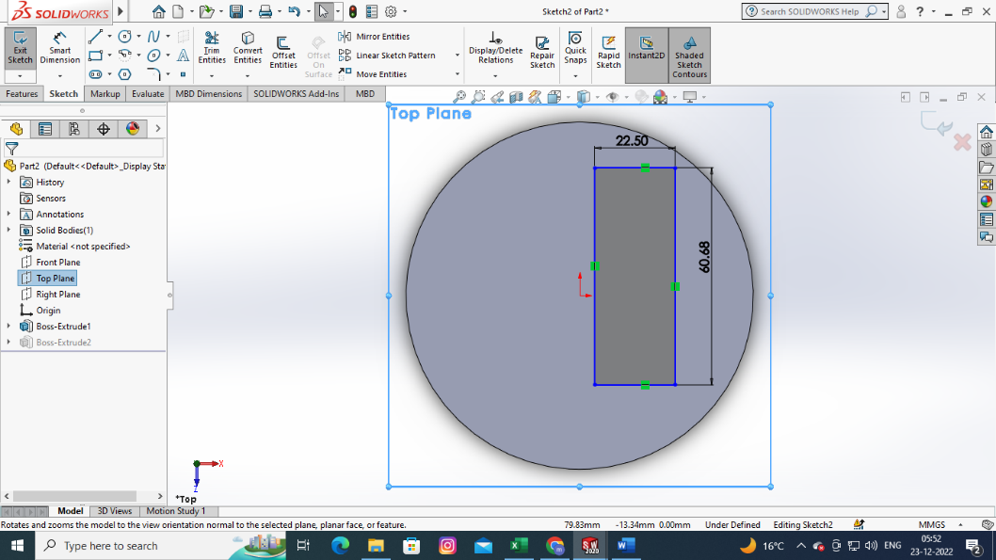

- Draw the reference line on rectangle with the height of 50 mm -> sketch-> spline-> draw the shoulder shape as shown in the fig -> features -> extrude boss base -> extrude to 5mm

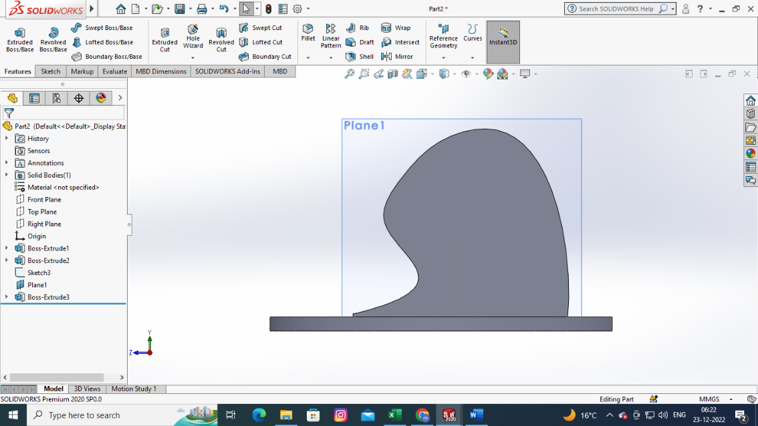
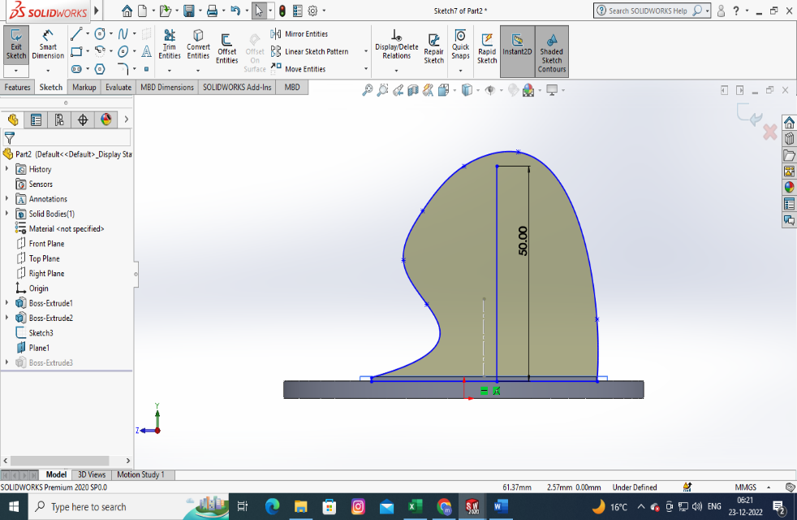

- Create a plane reference of 45degree for the arm : draw a line on shoulder plane and by using smart dimension change to 45 degree
- go to reference geometry planeselect first reference(line sketch) as line at 45 degrees second reference(face 1 % 360 deg) face 1 on which face to sketch the next profile and change the angle on which angle we want the profile.
- Draw a rectangle on the reference plane 41*21mm

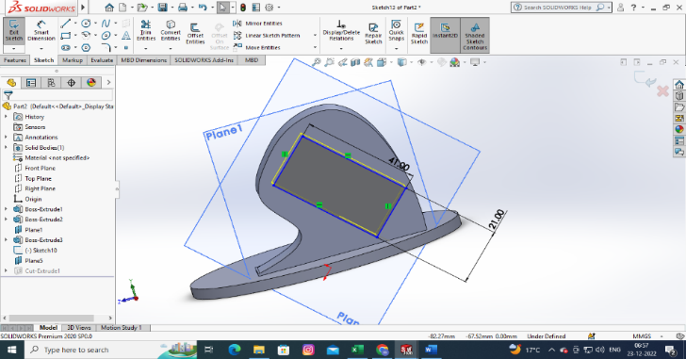
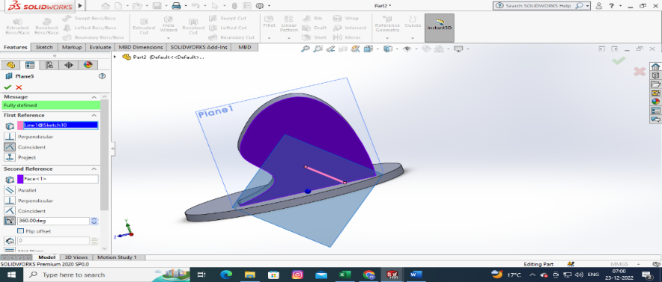

- Create a shaft cut for the servo motor shaft : sketch-> circle ->18 dia

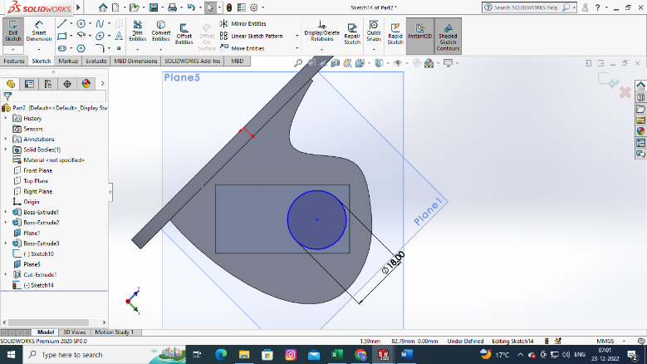
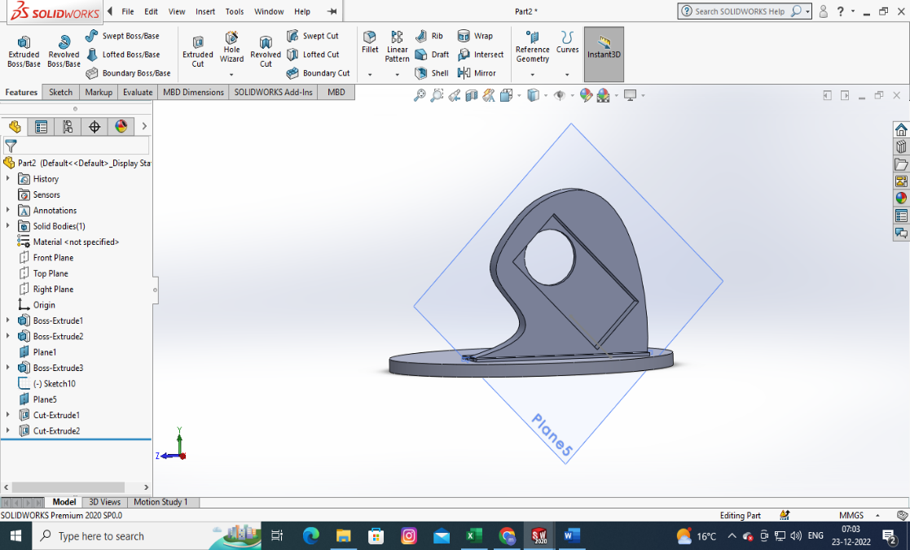

ROBOTIC ARM ELBOW
- Draw to circles with dia of 42 and extrude to 5mm go to sketch select spine and connect the circles extrude to 16mm

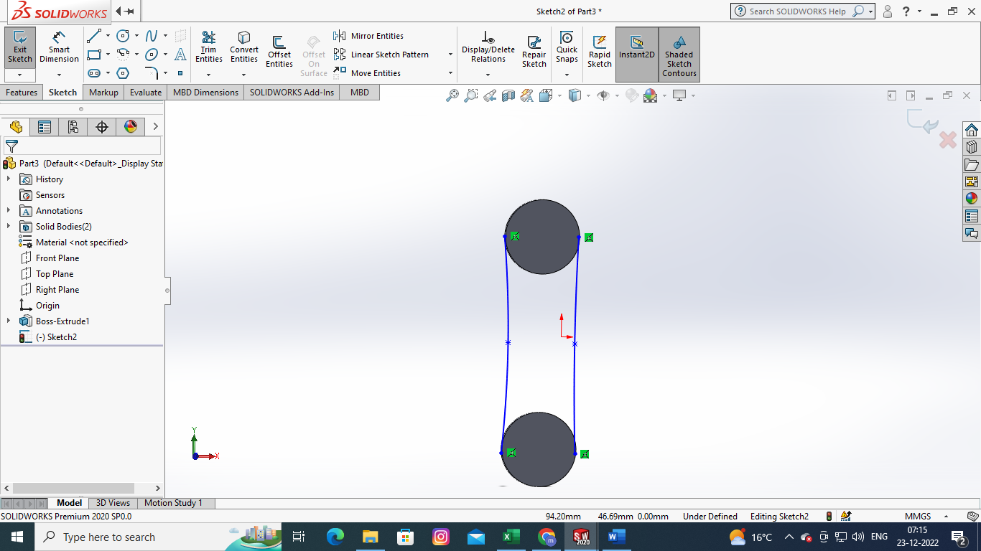
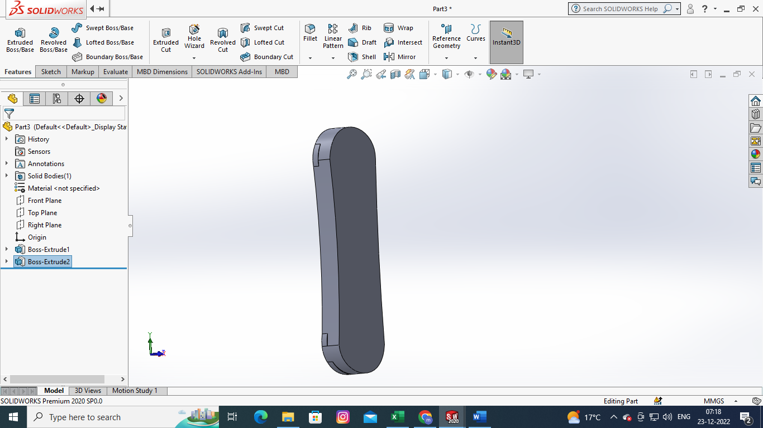
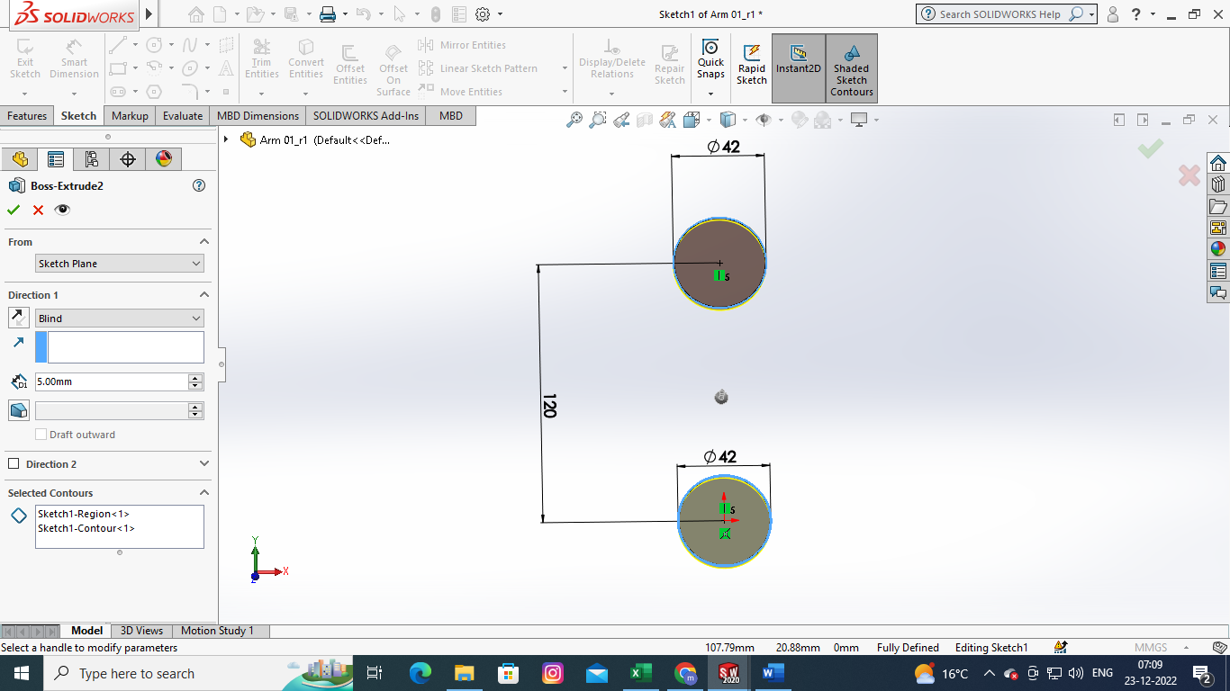

- Sketch a circle of 42mm and extrude cut-> fillets-> select fillets -> select the edges for fillet and select ok.
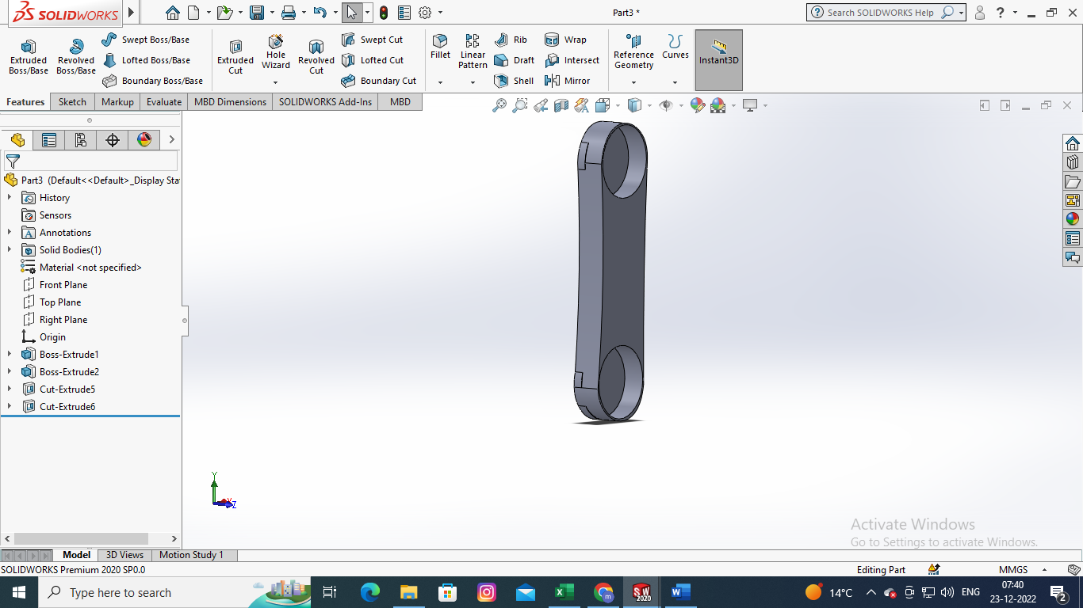
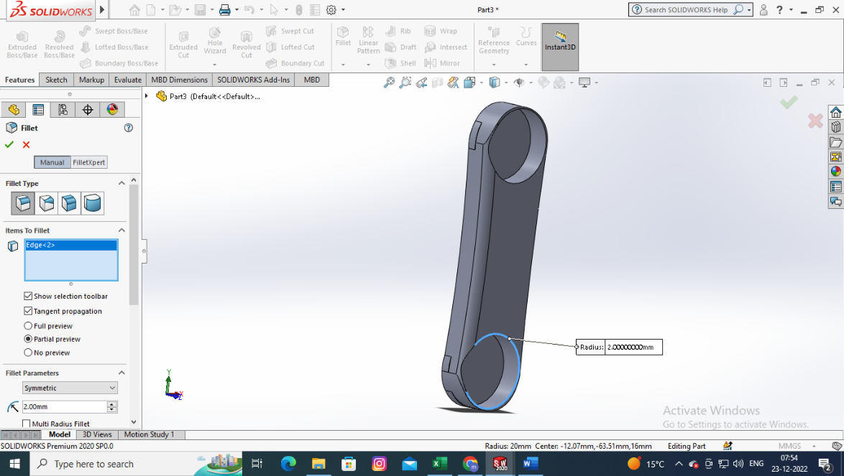

- Create screw holders for elbow and extrude cut

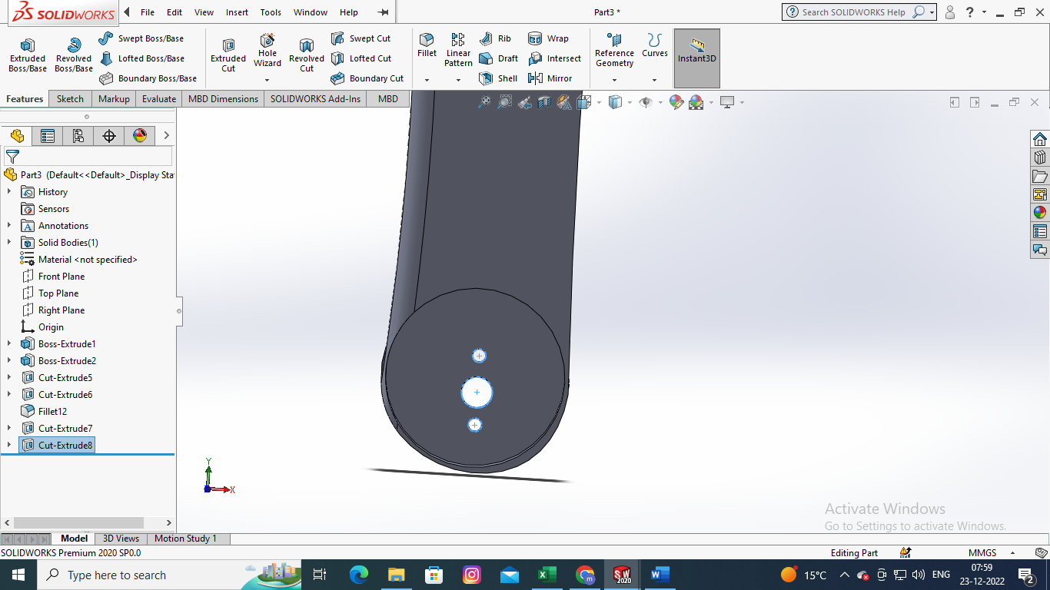
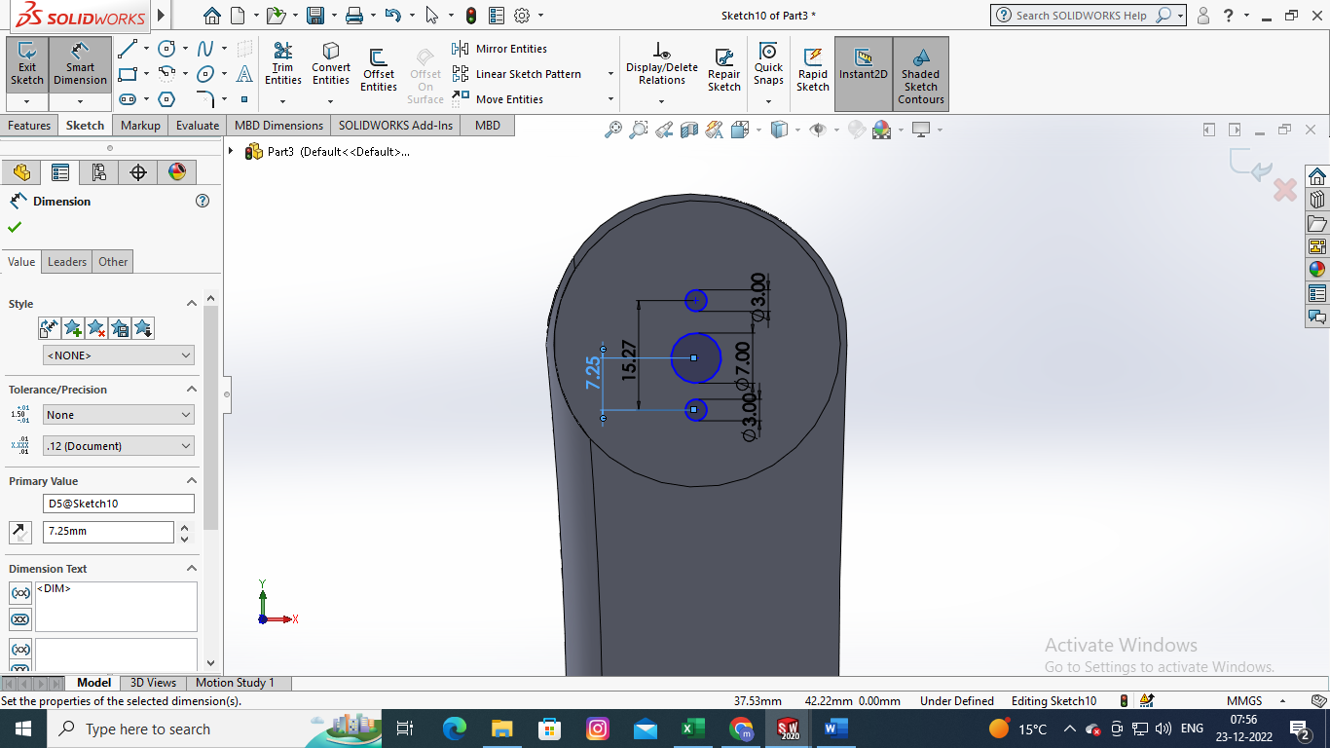

ROBOTIC ARM ELBOW 2
- Create a rectangle as shown in fig: 120mm and 38mm and extrude 15mm , create another rectangle for servo motor and extrude cut
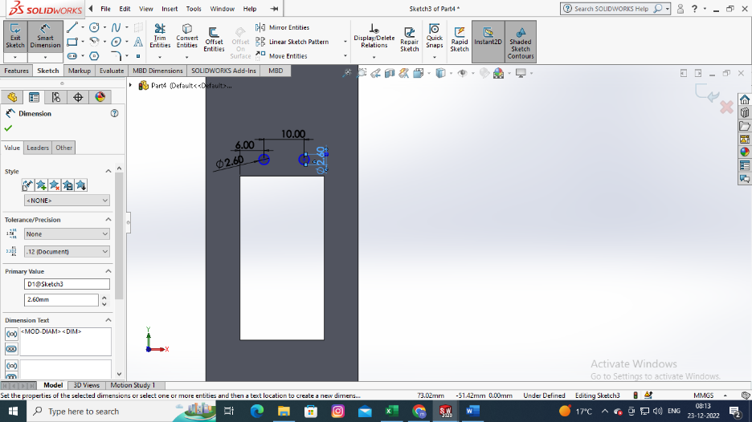
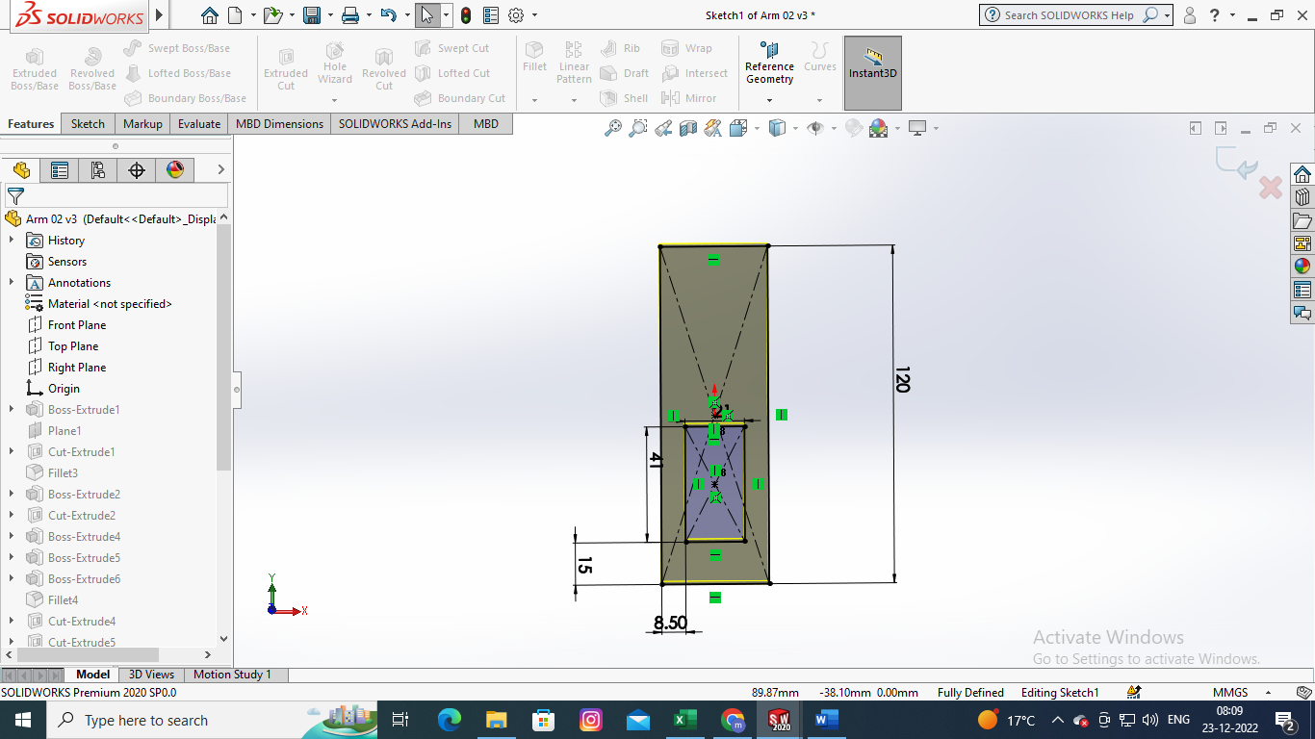
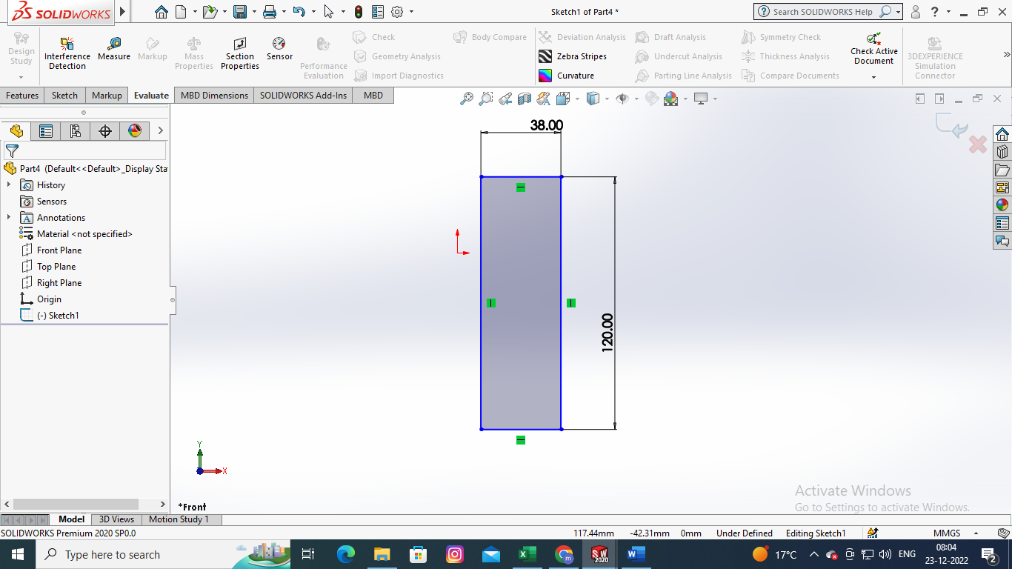

- Create slot for micro servomotor on the other side with the following dimensions and extrude cut and create screw slots for fixing servo motor and apply fillets to the model

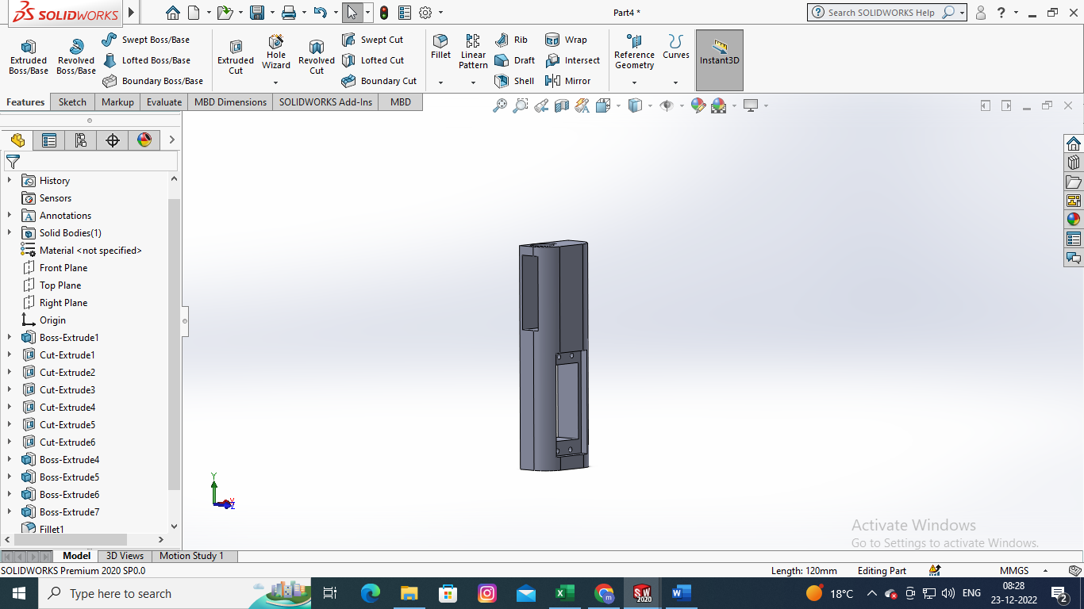
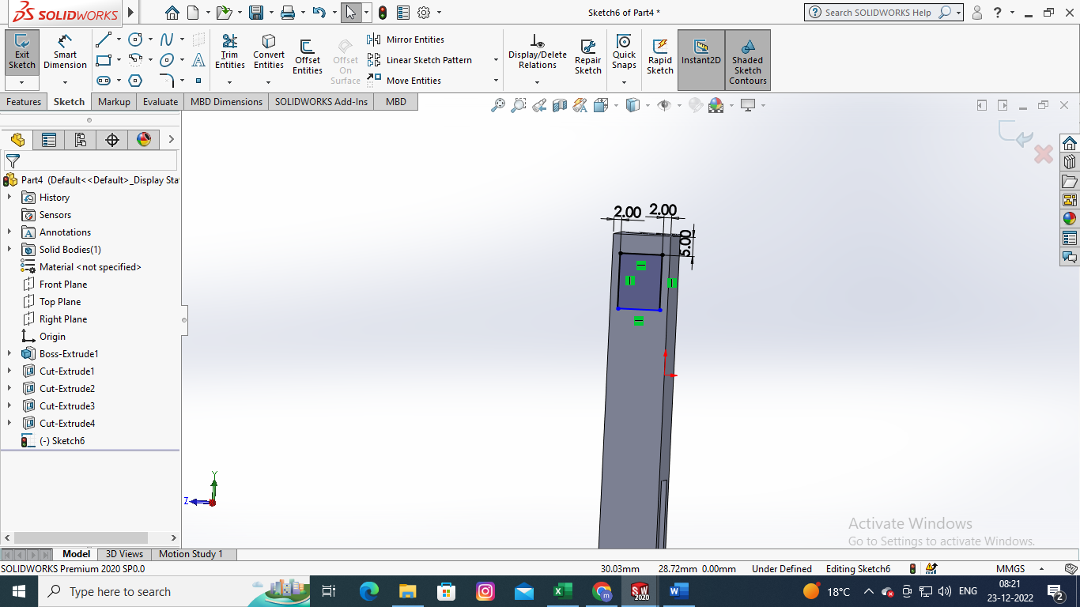
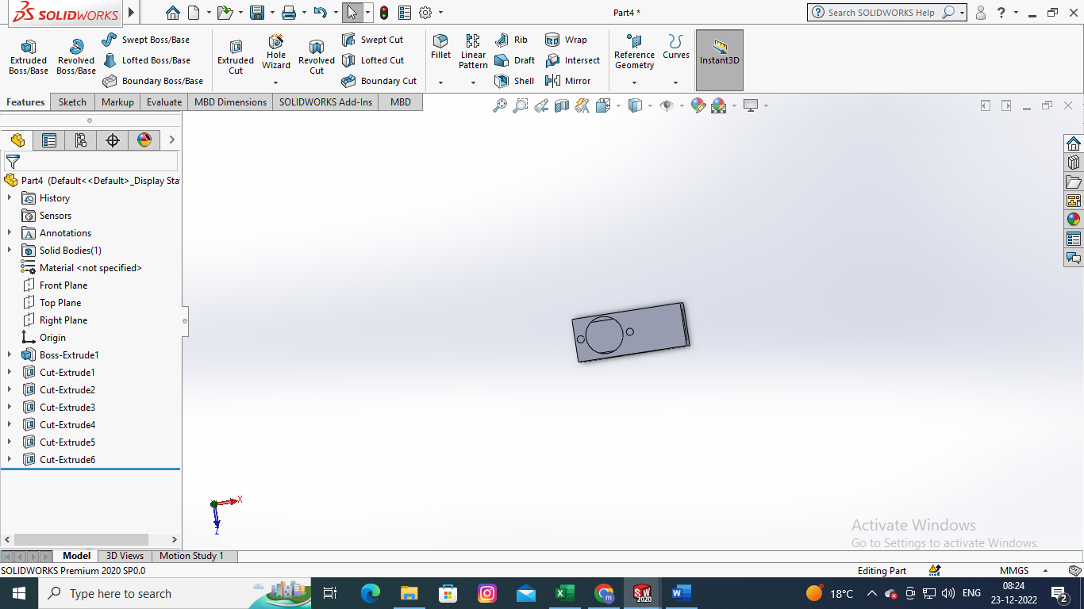
PP

